Sai Vineeth Reddy Suravi
Christian Brothers University
ECIS - 690-U Fall 2025 Comp Info Sys Capstone Project
Dr. Harichand Nair
November 27, 2025

Django
The Django framework is based on Python and encourages practical design and quick development. It is free and open source. It was built using the model-template-views (MTV) architecture. The Django Software Foundation, a 501(c)(3) nonprofit and self-governing entity in the United States, oversees keeping it up to date. Django is fast and fully loaded because it can handle content management, user authentication, and security features, while also helping prevent cross-site scripting and SQL injection. There is a lot of good documentation and resources available to assist novice developers in understanding and seeking assistance from experienced developers for any development project needs. (Patel, 2024)
Variances between Django and Python. (Patel, 2024)
The programming languages Django and Python are related but not identical. Python is a high-level language emphasizing object-oriented programming and providing extensive library support. Because of this, the execution of a wide variety of algorithms and programs is simplified. This tool is designed to assist programmers in writing code that is logical and free of errors for various applications. In comparison, Django allows us to create secure web apps using Python. Django includes the Admin Interface and SQLite3 files as basic functionality. Examples of how Python and Django differ.
Compilers use Python, which is a high-level and interpreted language. Django is built on top of Python.
The Model View-Template (MVT) framework.
In 1991, the Python Software Foundation made Python available to the public. The Django Software Foundation officially started the Django project in 2005. Django is widely utilized in web services and programs that work on the Internet. Writing applications is easier using Python. It is also software that is used for AI, computer applications, and data analysis.
People use Django to make websites, while Python is used to make tools like Web2py, Django, CherryPy, and Flask.
Pros for Django. (Tomazic, 2024)
Simple to Use: One of the nicest things about Django REST Framework is that we don't have to do anything to get it to function. We need to perform a pip install command, add the package to the list of installed applications, and then we can start making API. The framework fixes most of the difficulties that come up when implementing APIs. Instead of rebuilding the wheel, they may focus on app-specific endpoints. They can even build a complete API in only a few lines of code with the built-in serializers, view sets, and routers. DRF is great for developing generic CRUD (Create, Read, Update, Delete) APIs.
Mature and battle-tested: Django REST Framework has been around for over ten years. It is a structure that has been around for a long time and has been used in many battles. Many enterprises, including well-known ones like Mozilla, Red Hat, and Heroku, have used it throughout the years. Another good thing about DRF is that it was carefully planned. It features a modular architecture, which makes it easy to change out parts when they need to—for instance, the authentication, authorization system, or serialization layer. The framework also follows Django's rules. If we know how to use Django, it will be easy to find the way around DRF's source code.
Secure: Django REST Framework makes it easier to create APIs that are less likely to have bugs, easier to maintain, and safer. The library follows a code standard, and we must do the same. This helps us avoid typical pitfalls while creating APIs and makes it easier to get new developers on board. DRF also has a lot of built-in security features, such as CSRF protection, data validation, and request throttling.
Big Ecosystem: Most of the time, Django REST Framework works nicely with other popular
Django extensions. The framework has also built up a vast ecosystem of third-party products. In addition, a massive group of developers supports DRF. As of this writing, django-rest-framework has over 1,200 contributors on GitHub. It should be easy to obtain help if we ever get stuck.
Cons of Django. (Tomazic, 2024)
Hard to Learn: it's not too hard to get started using Django REST Framework. WE can do almost anything with the introductory API view class. The framework's real strength, though, is in its CBVs and ready-made courses for things like serialization, view sets, routing, and so on. If we are new to DRF, it could take us some time to understand them. But if we know them, we can trim our codebase in half, which will make our web app much "cleaner."
Problems with performance: The extra effort made by Django REST Framework might cause web project to run more slowly. The point of the package is to make it easy to construct APIs, not to make them as fast as possible. Compared to other serialization libraries like marshmallow and Serpy, its serialization procedure is rather sluggish. Tom Christie, the person who invented DRF, even said that shouldn't use serializers in views where speed is essential (source). When we serialize linked fields, they run into another difficulty. By default, DRF doesn't automatically optimize query sets that are sent to serializers using select related and prefetch related. That's how easy it is to talk about the N+1 problem.
Bad Separation of Concerns (SoC): The serialization layer in DRF requires too much effort. It oversees creating models, validating data, and serializing data. I've also seen several codebases
that put business logic in serializers.
Django Features. (Akash, 2024)
Mapping Objects to Relational Data: Django comes with Object-Relational Mapping, which
makes working with databases easier. It is an ORM that acts as a go-between for the database and an application, allowing developers to use Python instead of SQL to work with their database.
Rich Libraries and Tools: Django also has a lot of pre-installed libraries and tools that we may use. These utilities are meant to make tedious tasks like processing forms, routing URLs, and managing sessions easier.
Free and Open Source: Anyone may use Django without paying a licensing fee because it is open source. Its vibrant, open-source community keeps adding new features, keeping it current and competitive in the market.
Architecture of MVC/MVT: The Model-View-Controller (MVC) pattern is the basis for Django; however, it has been changed to the Model-View-Template (MVT) architecture. This design keeps the logic and display layers of an application distinct, allowing developers to handle different parts of the program independently.
Scalability and Flexibility: Django can grow without slowing down. It ensures that apps can be developed without needing major modifications to their construction, whether for a small startup or a large business.
How does Django Mechanism. (Jones, 2020)
The fact that the Django framework is built on the Model View Template design pattern is its most interesting feature. If not familiar with design patterns, let us quickly go over these parts. First, we have the Model, which is the most basic level of this design pattern. This level is where we may discover anything related to our website's database. A template is the top-level of the MVT design pattern. It is the section of the website that displays the user interface and serves as the presentation layer. Finally, we have View, which connects the two parts and is responsible for running the business logic and moving data from the website database to the Template. Django doesn't have a Controller as other popular design patterns like MVC do. This is because the framework handles all the tasks that a Controller would typically do, such as directing how the Model and View talk to each other. Due to Django, we don't have to write SQL code to make the database core. It only takes a few lines of Python code to create real databases. There are also a lot of other Django APIs that can help us with things like making our website safer by protecting it from CSRF attacks.
Python. (Koidan, 2022)
Brief about Python: Python is a programming language designed for a variety of purposes. This implies that it applies to a diverse array of applications, including software development, web applications, gaming, and task automation processes. Guido van Rossum, a Dutch programmer, developed Python, which was initially distributed in 1991. Python was primarily recognized as a scripting language during the 1990s and early 2000s. Python was also acknowledged as an exceptional instrument for data analysis and visualization with the advent of data science and machine learning. It became the most widely used language for data science and machine learning because its simple syntax allowed business analysts, data analysts, and others without programming experience to understand it easily. Additionally, it was already extensively used in organizations. Today, Python is still utilized for the automation of tasks and the development of software and web applications. However, the significant role that Python plays in data science is a substantial factor in its ongoing popularity. Therefore, Python proficiency is likely to increase our employment prospects, regardless of whether intend to pursue a career as a web developer, software developer, or data scientist.
Advantages & Disadvantage of Python.
Advantages. (Novotny, 2022)
Suitable for Rapid Development: Programs require less time to develop due to Python's
simplicity and absence of compilation requirements. Python programs are generally significantly shorter than their counterparts in other programming languages. It is an excellent option for the rapid construction of prototypes in a rapid software development environment.
Gentle Learning Curve: Python is a language that is relatively straightforward to learn and is an excellent choice for individuals who are beginning to learn how to program. Programmers who transition from languages such as C or Java to Python can achieve maximum efficacy in a short amount of time. An Integrated Development and Learning Environment (IDLE) is included in the Python installation.
Automatic Memory Allocation: Python does not have pointers, and developers are not required to allocate memory space. Python allocates memory automatically, and a garbage collector recycles memory from the discarded objects. This implies that developers are relieved of the burden of addressing scribblers, memory leakage, invalid pointer references, and the size of each object.
Free and Open Source: Under an open-source license, all Python releases are accessible for free. Python can be modified and redistributed at no cost. This significantly reduces the expenses associated with development. For additional details regarding Python licensing, consult the Python documentation website.
Disadvantages. (Novotny, 2022)
More likely to have runtime errors: Python is dynamically typed and is not compiled until runtime. Consequently, the compiler fails to identify numerous issues that would have been detected during the program's execution. A syntax error may be a straightforward example of this, but it can also encompass issues such as attempting to combine an integer and a string.
No Multithreading Support: Python does not support multi-threading due a its architecture.
Instead, it employs multiprocessing, which involves the execution of each thread in a distinct Python process. This depends on the operating system's supervision to schedule and balance the methods, which may not produce equally satisfactory outcomes.
Not Very Quick: Python is significantly slower than more efficient languages such as Java and C. Python is dynamically typed and interpreted, which means that the runtime compiler has a significant amount of work to complete. The type of each variable must be consistently verified. This implies that Python is not the optimal choice for situations in which performance is a critical factor.
Harder to Avoid Runtime Errors: Python is dynamically typed and is not compiled until runtime. Consequently, the compiler fails to identify numerous issues that would have been detected during the program's execution. A syntax error may be a straightforward example of this, but it can also encompass issues such as attempting to combine an integer and a string.
Used cases of Python. (Corbo, 2025)
Making and testing software: Python has a lot of libraries and pre-made modules that may be used for a wide range of tasks, such as web development, database interactions, API development, and server-side logic. Many programmers use it because its syntax is easy to comprehend. We may also use Python to test software by taking advantage of its ability to automate tasks. With Python, developers can construct scripts that perform actions like clicking buttons or making API calls, so they don't have to test things by hand.
Automating: Automation is one of Python's key advantages as a programming language, and it is commonly used for this purpose. Scripting lets programmers construct a list of steps that a computer should follow when it runs a script. Renaming files, altering CSV files, and extracting data from a website are all common scripts. A lot of this is feasible since Python has a straightforward syntax and works with a lot of other libraries.
Analytics and Data Science: A lot of data scientists and analysts utilize Python. The language has built-in functions for reading and writing files, which help gather, clean, categorize, and analyse large volumes of data. Data scientists may also use Python to construct machine learning models with the data they have collected, allowing them to explore it further or make predictions.
NumPy. (Dunbar, n.d.)
The NumPy library is a free and open-source utility that facilitates the efficient manipulation of arrays. In 2005, Travis Oliphant coined the term "numerical Python," which stands for "numerical Python." Nevertheless, it is a Python library developed by a group of intelligent individuals to facilitate numerical operations. One of the most critical data science libraries in Python is reliant on numerous other libraries. Assume that the user desires to perform mathematical and logical operations on arrays. In that scenario, this Python package is a highly favoured option for scientific computation due to its ability to support this process. NumPy is a scripting language that is dependent on Python. When it comes to facilitating computation at scale, NumPy is one of the most frequently used Python tools by developers and data scientists. It includes libraries and methods for manipulating matrices and arrays, facilitated by programs written in high-speed languages like Fortran, C++, and C. Furthermore, NumPy is not constrained by Python's limitations, such as memory inefficiency and decreased execution speed, because it performs all operations outside the Python interpreter. The NumPy array is a sophisticated N-dimensional array object that is organized in rows and columns. Column-based. We can access the elements of NumPy arrays and initialize them using nested Python lists.
NumPy’s advantages. (Dunbar, n.d.)
Mathematical operations on NumPy's array objects are up to 50 times quicker than iterating
over native Python lists using loops. NumPy's efficiency advances are primarily due to storing array elements in a single, ordered location within memory, eliminating redundancies by ensuring all components are of the same type, and utilizing the full capabilities of modern CPUs. When working with arrays containing thousands or millions of elements, which are common in data science, the efficiency advantages become particularly apparent.
It provides an indexing syntax that enables users to access specific sections of data within an array effortlessly.
It includes built-in functions that enhance the quality of life when working with arrays and mathematics, including functions for linear algebra, array transformations, and matrix math.
It requires fewer lines of code for most mathematical operations than native Python lists.
NumPy’s disadvantages. (Hanna, 2022)
Those are simpler to alter. It is much simpler to add and remove elements from lists since each component of a list is stored in its own separate location. Elements are stored in NumPy arrays at continuous positions; therefore, addition and deletion require the elements to be shifted, which is a time-consuming process.
Expand dynamically, but NumPy arrays are always of the same size.
They are constructed into the system. To make use of NumPy arrays, we need to import an external library because they are not built into the language.
How to install NumPy. (Ravindranath, 2022)
Step1: Before installing NumPy, we must ascertain our Python version. Most operating systems include Python pre-installed, except for Windows, which necessitates manual installation.
Execute the command below to verify the presence of Python 2.
python -V, to Python 3: python3 -V
Step2: Pip is a package manager for Python that facilitates the installation and management of Python software packages. Pip is often not pre-installed on most operating systems. Consequently, it is necessary to install the package management corresponding to our version of Python. Install both versions of Pip if we possess both versions of Python. In Windows, we
Step3: After installing Pip, use the command below to install NumPy.
In Python2: pip install NumPy, In Python3: pip3 install NumPy. The terminal will display the successfully installed versions of NumPy.
Step4: Execute the following command to verify if NumPy has been installed and is included in our Python packages.
For Python2: pip show NumPy, For Python3:pip3 show NumPy.
Capstone Development:
Develop a machine-learning powered web application that flags students likely to drop out, remain enrolled, or graduate (three-class classification). Early detection will enable universities to deploy targeted support and improve retention rates.
Dataset Information
- Source: “Predict Students’ Dropout and Academic Success” (donated 12 Dec 2021)
- Size: 4 424 rows × 36 features
- Features: mix of demographic, socio-economic & academic variables
- Task: multi-class classification (imbalanced) that is dropout / enrolled / graduate
- Source of the dataset: https://archive.ics.uci.edu/dataset/697/predict+students+dropout+and+academic+success
Here’s a condensed requirements specifications in 5 points based on everything we did as part of this capstone project:
1. ML Model & Data Pipeline
Use the “Predict Students' Dropout and Academic Success”dataset (4424 rows, 36 features, 3-class target: Dropout / Enrolled / Graduate).Perform preprocessing, train multiple models (logistic regression, random forest, gradient boosting, SVC), evaluate with accuracy + macro precision/recall/F1, select the best model (gradient boosting in your case), and save it as `best_student_dropout_model.pkl`. The Django app must load this pickle and use the same feature order and data types as in training.
2. Core Django Application (No virtualenv, local setup)
Implement pages: Custom Registration, Login, Prediction Form, Result Page, History Page, and a Static Field Info Page. Registration: custom user form with first name, last name, phone, email, DOB (no future dates, HTML date picker with `max=today`).
3. Prediction Form Details (UX + Validation)
All coded categorical fields (marital status, application mode, course, application order, nationality, parents’ qualification/occupation, yes/no flags, daytime/evening, gender, etc.) must be rendered as dropdowns, with choices taken from the dataset codes and converted to integers via `TypedChoiceField(coerce=int)`.
4. History, Field Info & Navigation
History page: table listing each user’s past predictions (date, course, application order, admission grade, 1st & 2nd sem grades, prediction result with colored badges, plus a “View” link to the detailed result). Field Info static page explains every field in plain language, including meaning and typical ranges
5. Admin & Backend Management
Django admin must register `Prediction History` with a customized `ModelAdmin`, `list_display` includes user, created_at, course, application order, key grades, and prediction_result. Filters for prediction_result, course, gender, scholarship_holder, displaced, international, created_at.
Core Technology Stack
Data Science & ML: Python 3, NumPy, Pandas, Scikit-learn,Pickle
Web Framework: Django
Database: SQLite 3
Front-End: HTML 5, CSS 3, Bootstrap 5
IDE: VS Code
Important Screenshots in the Application:
Below is the user registration page:
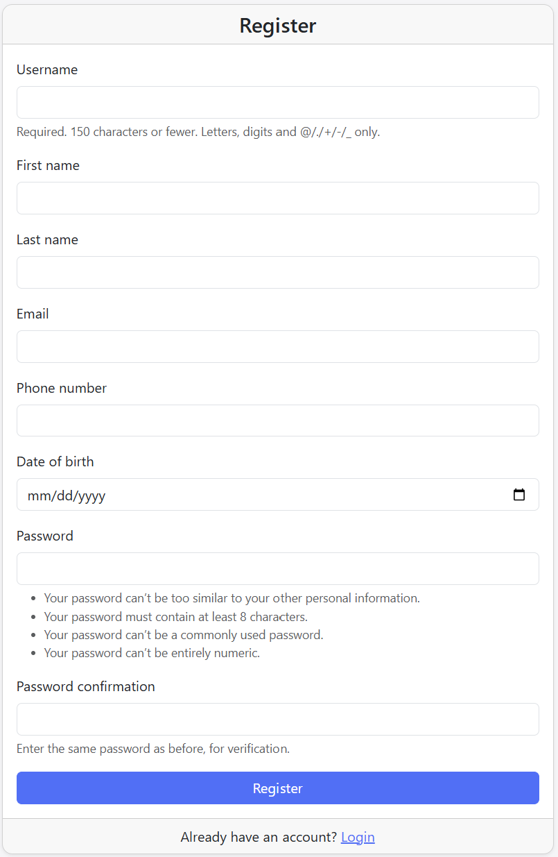
Figure 1:User Registration Form
Login Form:
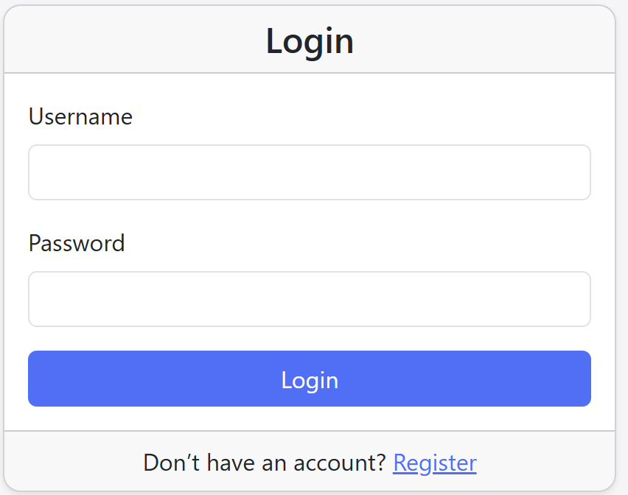
Figure 2: Login Form
History Page:
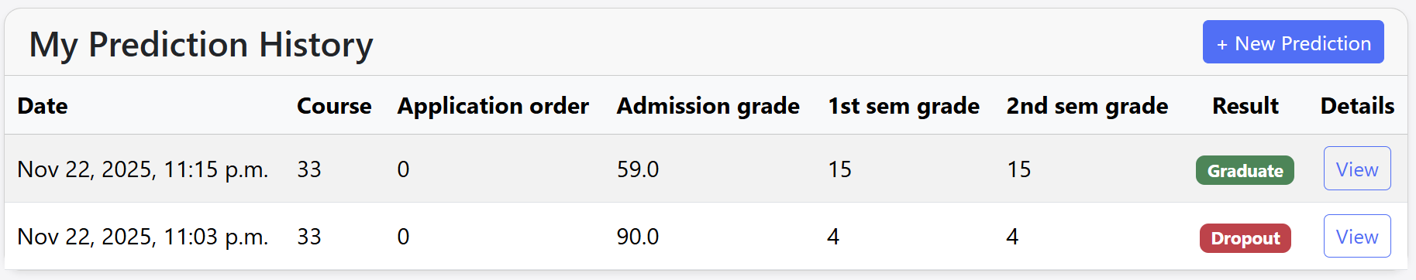
Figure 3:History Page
Prediction form’s field information Page:
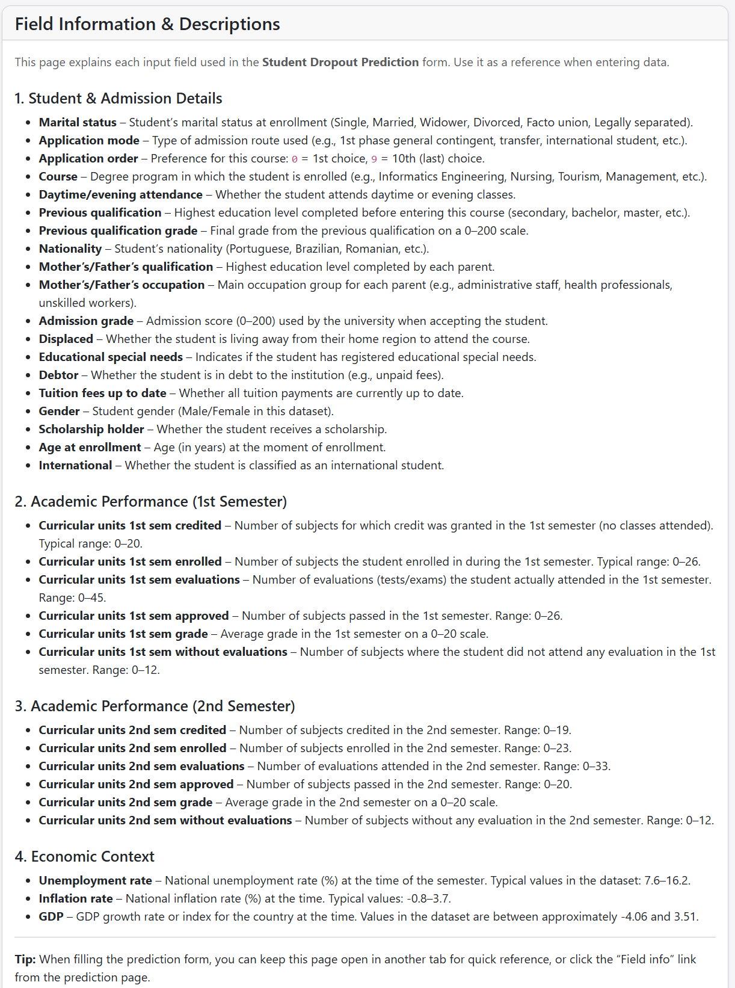
Figure 4: Field Information Page
Prediction Form:
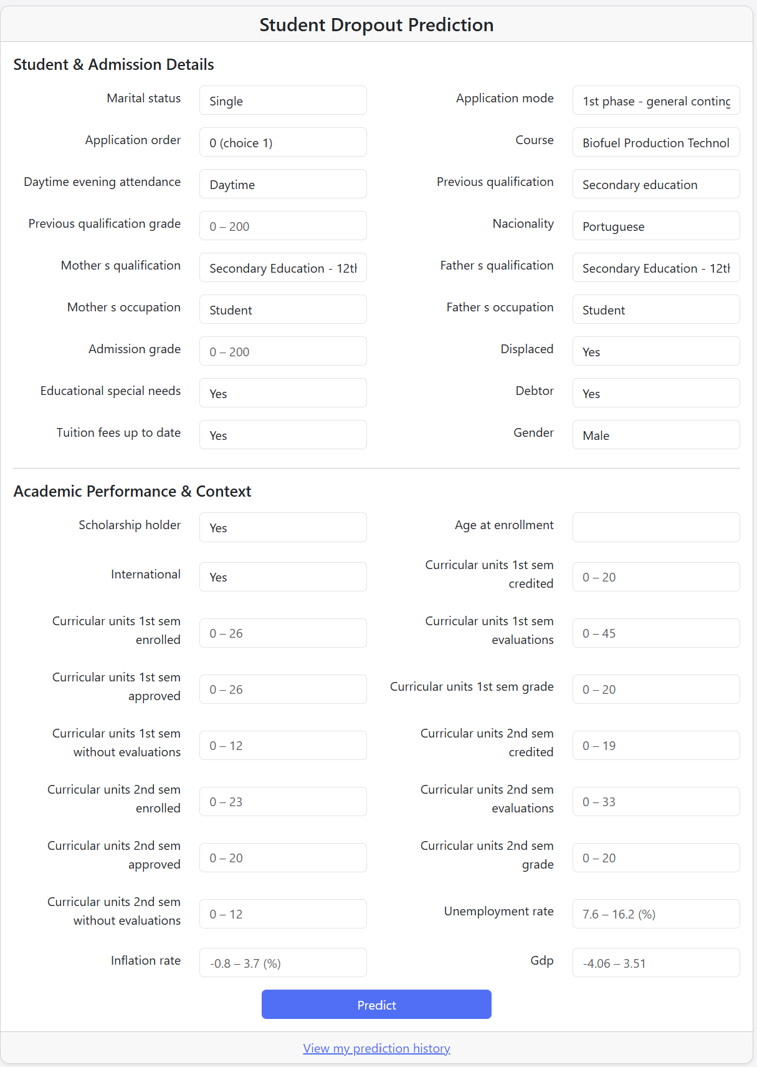
Figure 5: Prediction Form
Prediction Result Page:
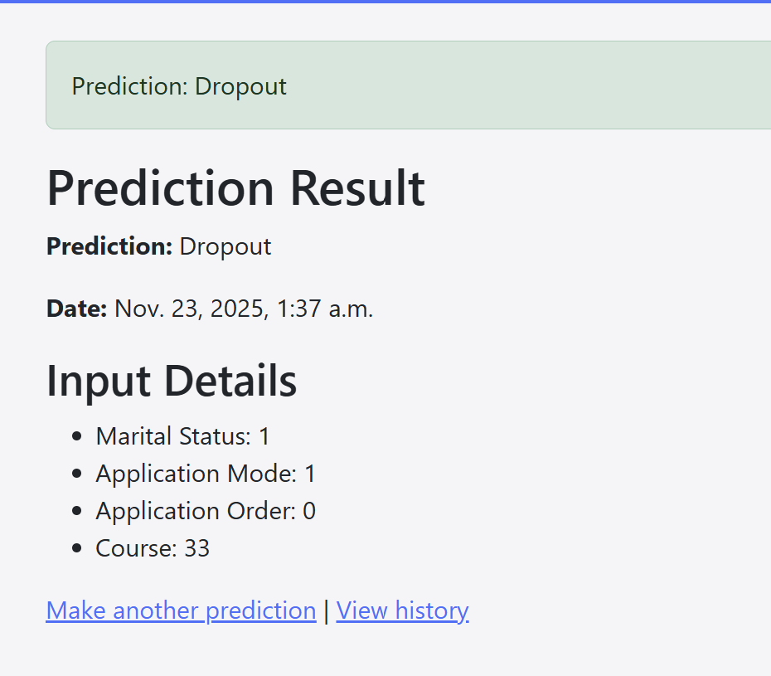
Figure 7: Prediction Result Display Page
Admin Panel:
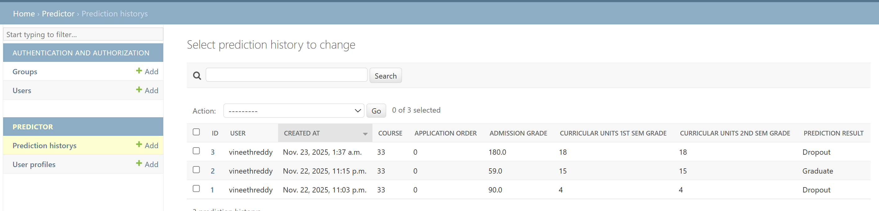
Figure 8: Admin Panel
Number of Python/data science libraries used in the project:
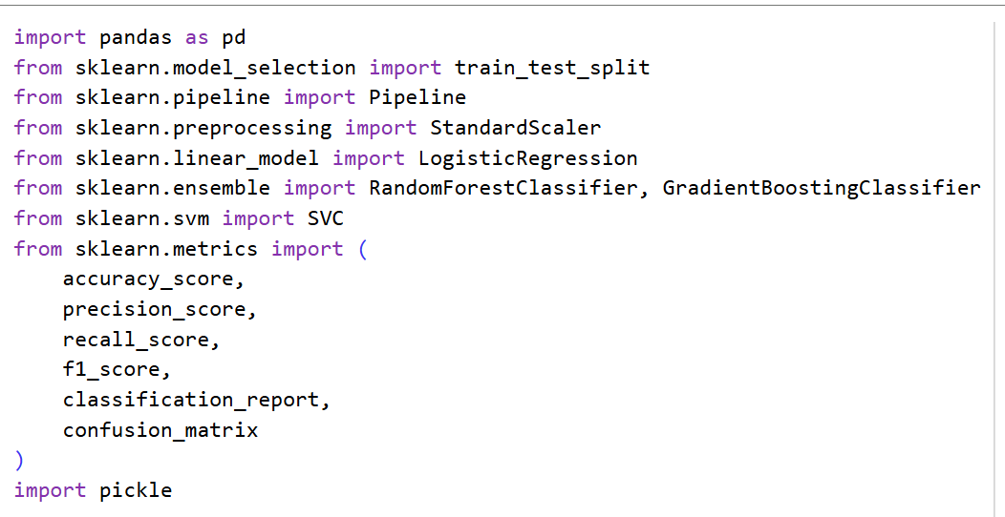
Figure9:Libraries used in the project
Important Django commands used in the project:
1. django-admin startproject student_dropout_project
Creates a new Django project with the basic configuration and folder structure.
2. py manage.py startapp predictor
Creates a new Django app named predictor to hold models, views, forms, and templates.
3. py manage.py makemigrations
Generates migration files based on changes made to the Django models.
4. py manage.py migrate
Applies the generated migrations to the database, creating or updating tables.
5. py manage.py runserver
Starts the Django development server so the project can be accessed in a web browser.
6. py manage.py createsuperuser
Creates an administrator account to log in to the Django admin site.
ML Models used for best model evaluation:
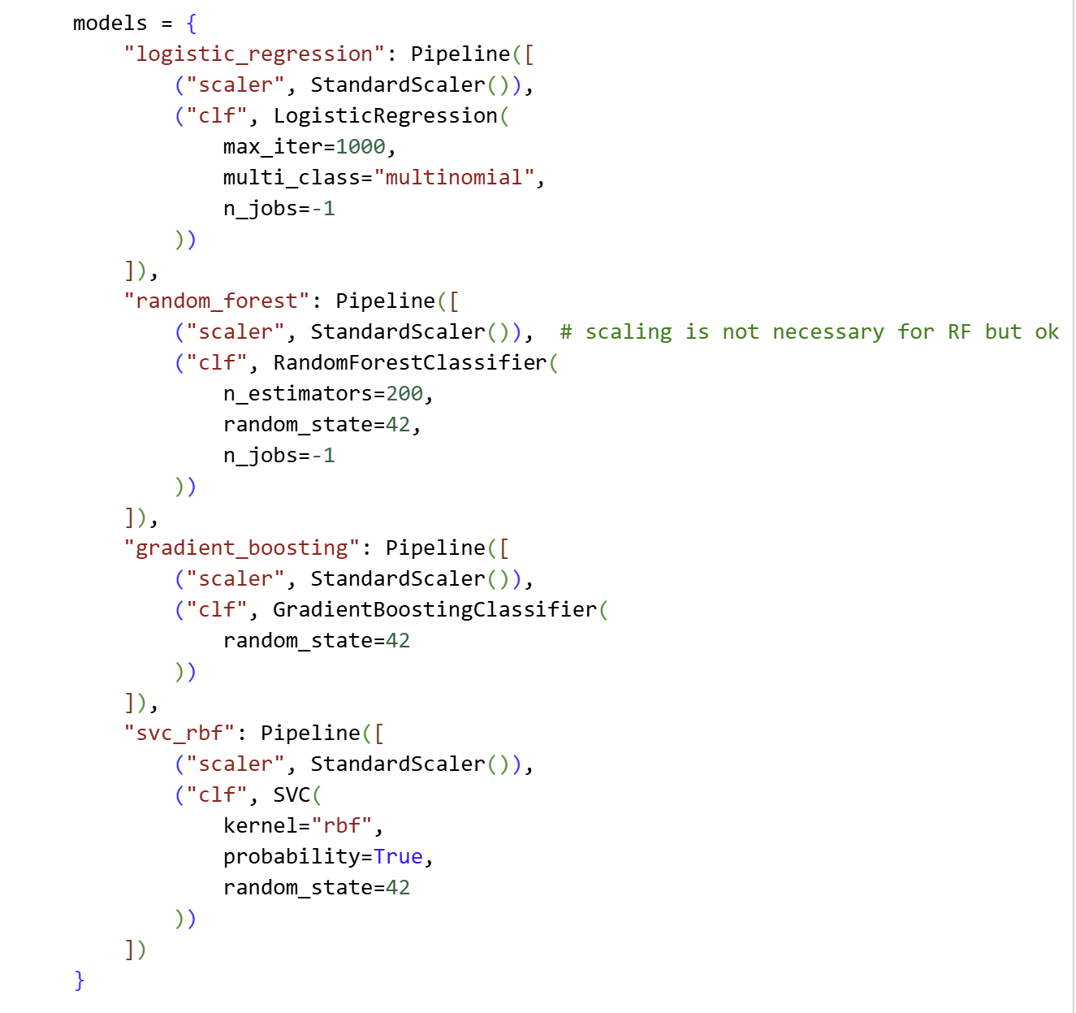
Figure 10: ML Models
ML Model Evaluation Parameters:
- Accuracy measures the overall proportion of correct predictions out of all predictions made.
- Precision (macro) is the average, across all classes, of how many predicted positives for each class are actually correct.
- Recall (macro) is the average, across all classes, of how many actual instances of each class are correctly found by the model.
- F1-score (macro) is the average, across all classes, of the harmonic mean of precision and recall, balancing both for each class.
ML Model Results:
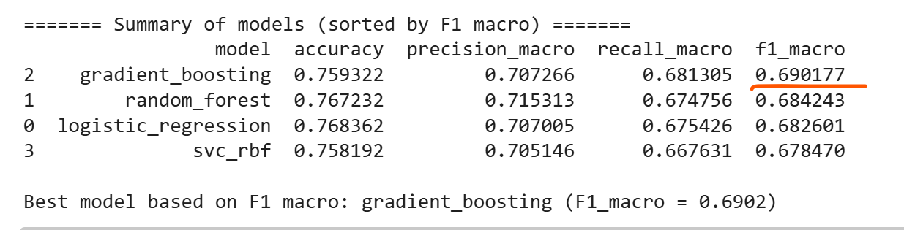
Dataset Columns:
1. marital_status – Student’s marital status at enrollment.
2. application_mode – Type of admission route used to enter the course.
3. application_order – Preference rank for this course (0 = first choice, 9 = last choice).
4. course – Degree program the student enrolled in.
5. daytime_evening_attendance – Indicates whether the student attends daytime or evening classes.
6. previous_qualification – Highest education level completed before joining the program.
7. previous_qualification_grade – Grade of the previous qualification (0–200 scale).
8. nacionality – Student’s nationality.
9. mother_s_qualification – Mother’s highest completed education level.
10. father_s_qualification – Father’s highest completed education level.
11. mother_s_occupation – Mother’s occupation group.
12. father_s_occupation – Father’s occupation group.
13. admission_grade – Admission score used by the university during enrollment.
14. displaced – Indicates if the student lives away from their home region to study.
15. educational_special_needs – Whether the student has registered special educational needs.
16. debtor – Indicates if the student is in debt to the institution.
17. tuition_fees_up_to_date – Status of tuition fee payments.
18. gender – Student’s gender.
19. scholarship_holder – Whether the student receives a scholarship.
20. age_at_enrollment – Student’s age at the moment of enrollment.
21. international – Indicates if the student is an international student.
22. curricular_units_1st_sem_credited – Number of curricular units credited in the 1st semester.
23. curricular_units_1st_sem_enrolled – Number of units enrolled in the 1st semester.
24. curricular_units_1st_sem_evaluations – Number of evaluations taken in the 1st semester.
25. curricular_units_1st_sem_approved – Number of units approved in the 1st semester.
26. curricular_units_1st_sem_grade – Average grade in the 1st semester (0–20).
27. curricular_units_1st_sem_without_evaluations – Units without evaluations in the 1st semester.
28. curricular_units_2nd_sem_credited – Number of curricular units credited in the 2nd semester.
29. curricular_units_2nd_sem_enrolled – Number of units enrolled in the 2nd semester.
30. curricular_units_2nd_sem_evaluations – Number of evaluations taken in the 2nd semester.
31. curricular_units_2nd_sem_approved – Number of units approved in the 2nd semester.
32. curricular_units_2nd_sem_grade – Average grade in the 2nd semester (0–20).
33. curricular_units_2nd_sem_without_evaluations – Units without evaluations in the 2nd semester.
34. unemployment_rate – National unemployment rate (%) at the time.
35. inflation_rate – National inflation rate (%) at the time.
36. gdp – GDP growth rate or index during the study period.
37. target – Final academic outcome: Dropout, Enrolled, or Graduate.

References
Akash, K. (2024, November 24). Key Features of the Django Framework
https://www.analyticsinsight.net/tech-news/key-features-of-the-django-framework
Corbo, A. (2025, July 21). What is Python?
https://builtin.com/software-engineering-perspectives/python
Dunbar, R. (n.d.). Python NumPy Tutorial: An Applied Introduction for Beginners.
https://www.learndatasci.com/tutorials/applied-introduction-to-numpy-python-tutorial/
Hanna, J. (2022, November 29). Why Use NumPy Instead of List Operations?
https://blog.finxter.com/why-use-numpy-instead-of-list-operations/#content
Jones, B. (2020, November 28). What is Django, and how does it work?
https://www.codeunderscored.com/what-is-django-and-how-does-it-work/
Koidan, K. (2022, October 26). Why Python is a Good Programming Language.
https://learnpython.com/blog/python-is-good-programming-language/
Novotny, J. (2022, March 23). The Pros and Cons of Python Programming
https://www.linode.com/docs/guides/pros-and-cons-of-python/
Pater, J. (2025, October 20). What is Django Used For? Should You Use Django in Web Development
https://www.monocubed.com/blog/what-is-django-used-for/
Ravindranath, S. (2022, April 21). What is NumPy in Python — Introduction to NumPy — NumPy Tutorial
https://medium.com/edureka/python-introduction-to-numpy-numpy-tutorial-4ac06c717971
Tomazic, N. (2024, February 29). Django REST Framework: Pros and Cons
https://testdriven.io/blog/drf-pros-cons/

